**Hospital Management System:**

Hospital Management Systems (HMS) play a pivotal role in modern healthcare by efficiently managing and organizing a multitude of tasks within a healthcare facility. These systems are designed to streamline processes, enhance patient care, and ensure smooth administrative operations. A well-structured database is the backbone of any Hospital Management System, providing the foundation for storing, retrieving, and managing vast amounts of healthcare-related data. In this database project, we embark on creating a comprehensive DB Schema for a Hospital Management System, incorporating essential database concepts like Views, Relationships, Indexing, Stored Procedures, and Triggers. The objective is to design a robust and scalable system that not only caters to the current needs of healthcare management but also adapts to future requirements seamlessly.

**Objectives :**

● Design and implement a robust database schema.

● Utilize database concepts for optimized data retrieval and manipulation.

● Implement a practical solution using a Relational Database System (MySQL).

● Enable HMS to recognize registered patients and user roles.

● Develop necessary queries for user role registration, diagnosis addition, patient details retrieval, and bill preparation.

● Implement optimizations using views/materialized views, indexing, and stored procedures.

● Introduce triggers to indicate when a patient's medical insurance limit has expired.

**Create a DB Schema for Hospital Management System.**

* I have created a database named as ‘**mydb.sql**’

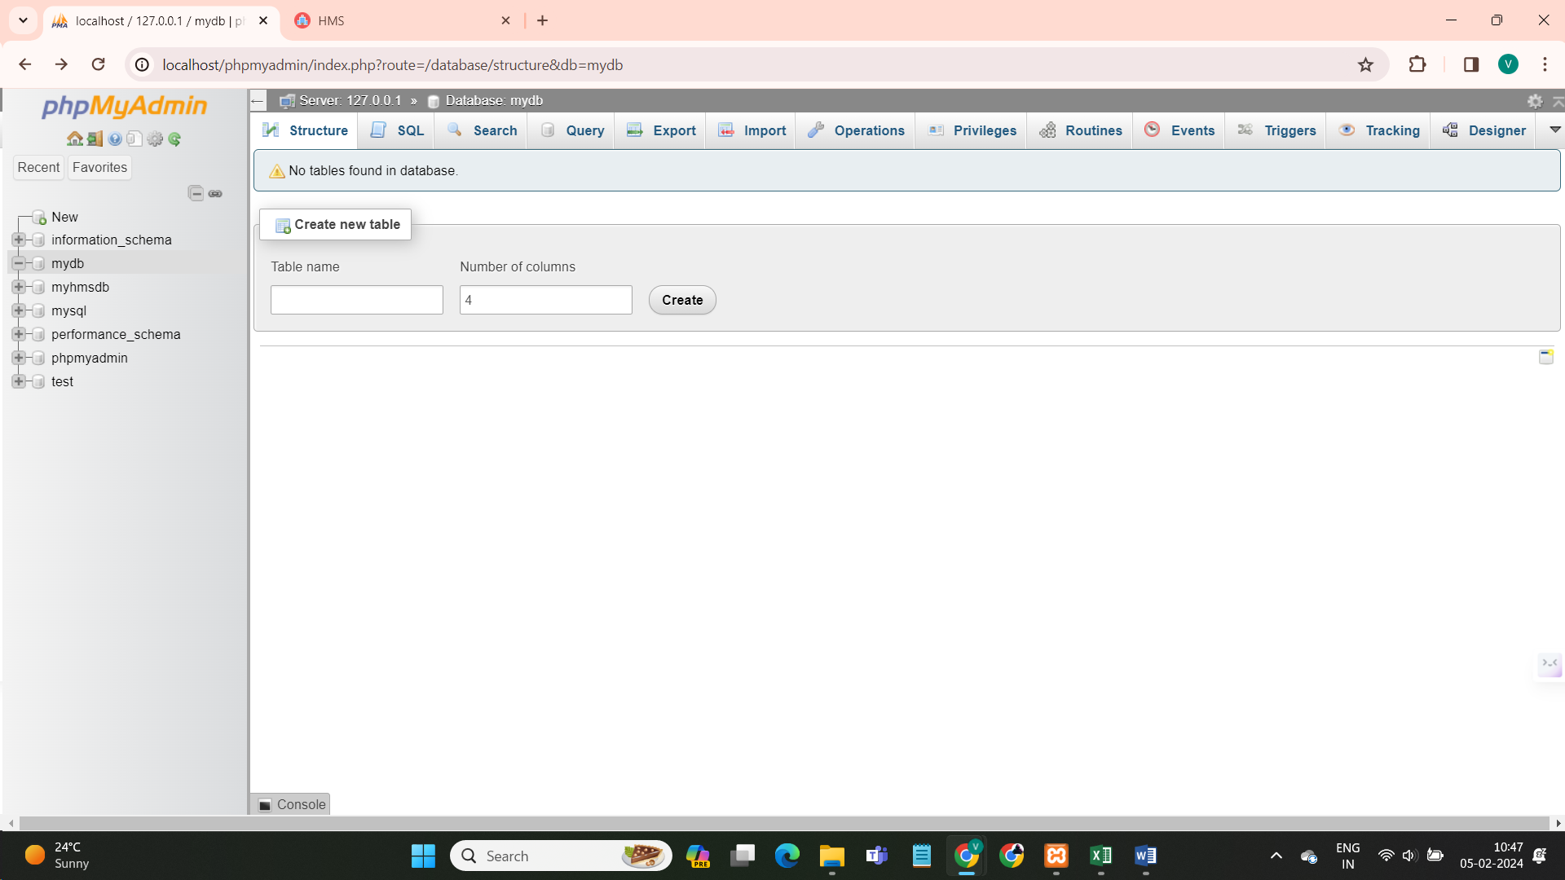

Define the schema along with the constraints indicating the relationships between the entities.

1. **Created ‘Patients’ Table :**

SQL Queries-

CREATE TABLE Patients (

PatientID INT PRIMARY KEY AUTO_INCREMENT,

FirstName VARCHAR(50),

LastName VARCHAR(50),

Gender VARCHAR(10),

DateOfBirth DATE

-- ... other patient details

);

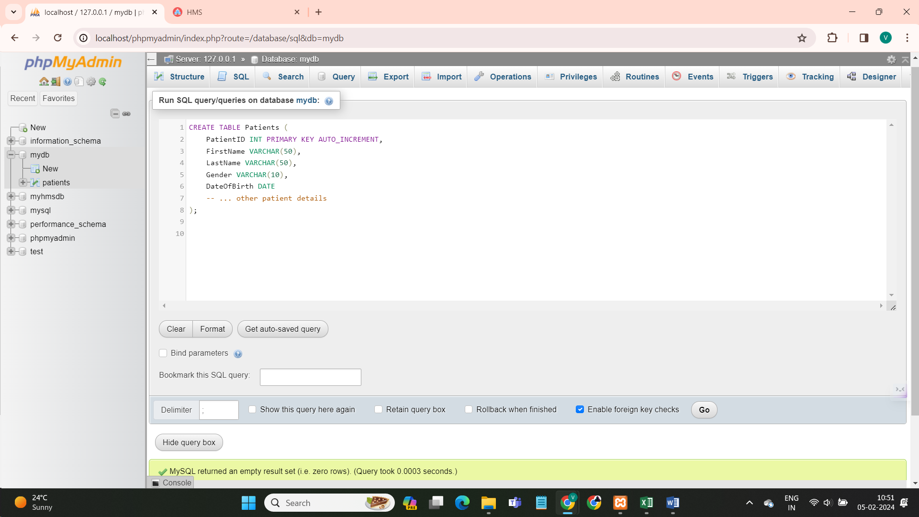

1. **Roles Table:**

SQL Queries-

CREATE TABLE Roles (

RoleID INT PRIMARY KEY AUTO_INCREMENT,

RoleName VARCHAR(50)

-- ... other role details

) 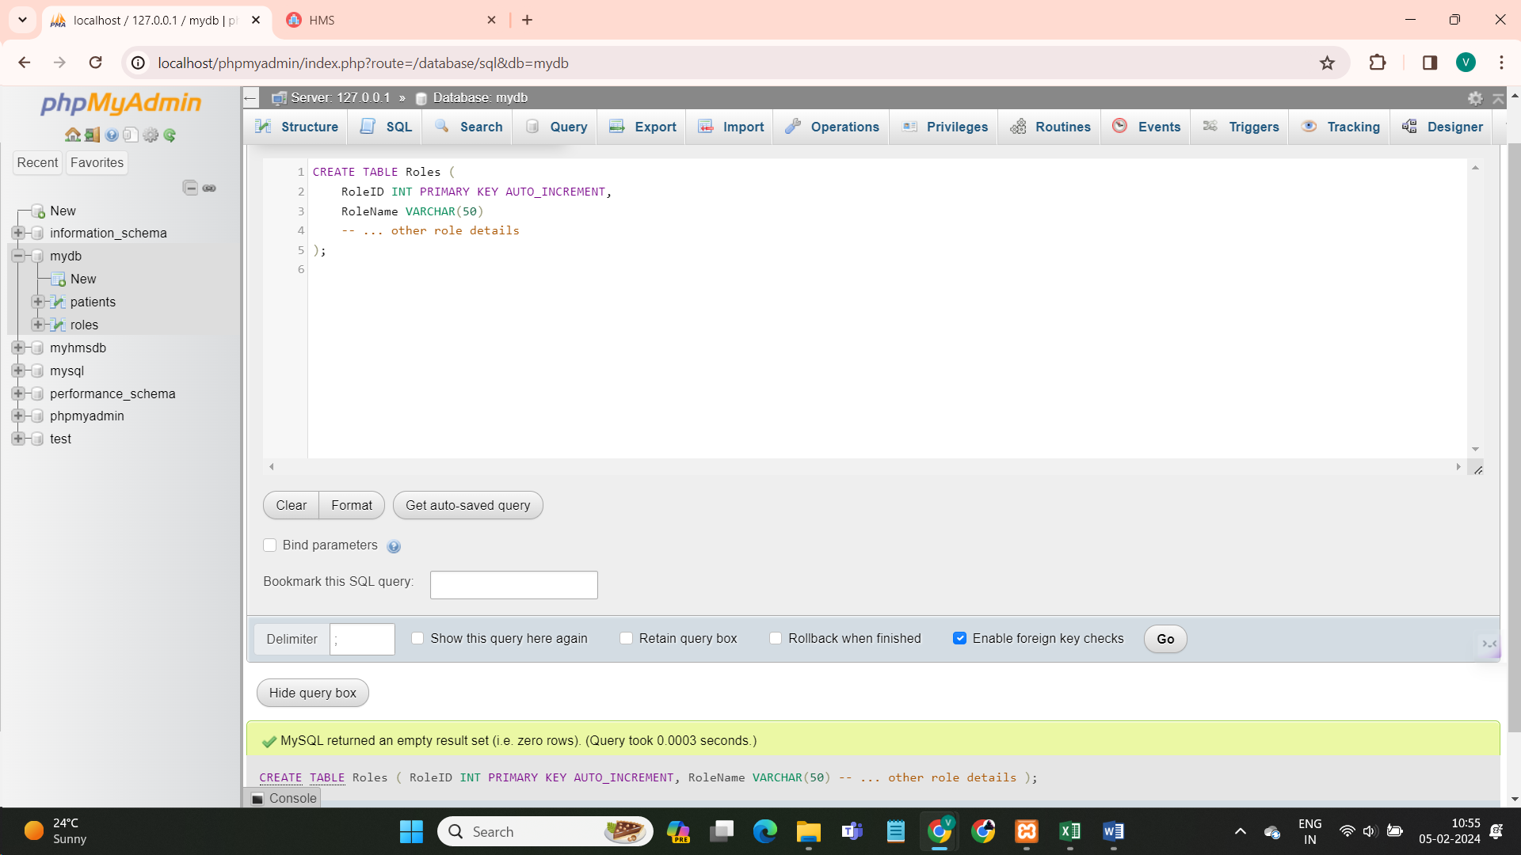

1. **Users Table:**

SQL Queries-

CREATE TABLE Users (

UserID INT PRIMARY KEY AUTO_INCREMENT,

UserName VARCHAR(50),

Password VARCHAR(50),

RoleID INT,

FOREIGN KEY (RoleID) REFERENCES Roles(RoleID)

-- ... other user details

);

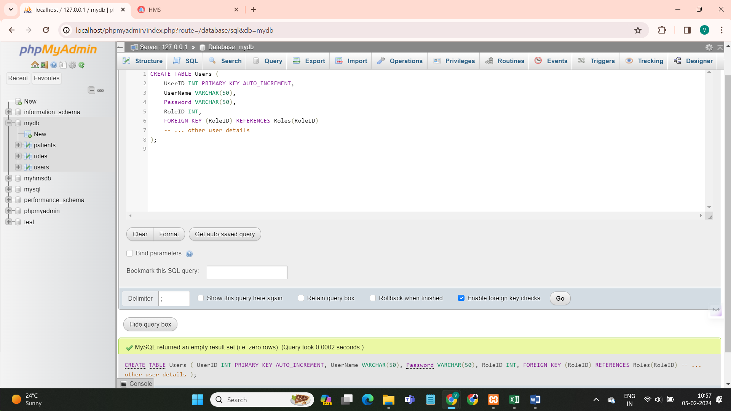

1. **Diagnosis Table:**

SQL Queries-

CREATE TABLE Diagnosis (

DiagnosisID INT PRIMARY KEY AUTO_INCREMENT,

PatientID INT,

DiagnosisDate DATE,

DiagnosisDetails TEXT,

FOREIGN KEY (PatientID) REFERENCES Patients(PatientID)

-- ... other diagnosis details

);

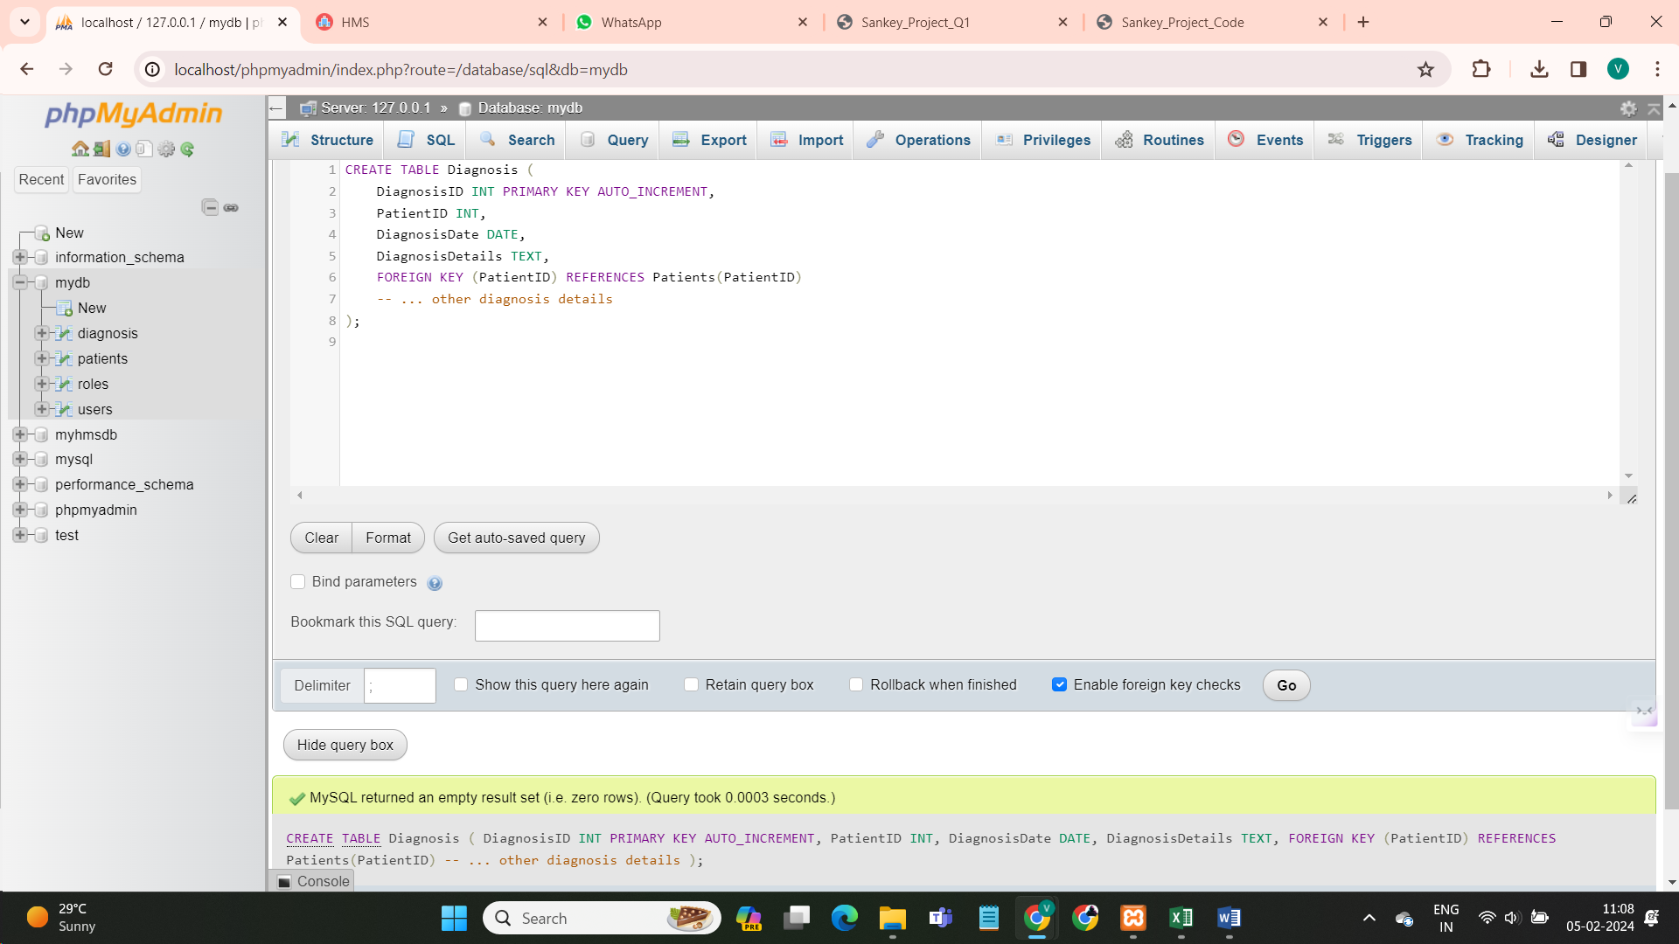

1. **Bill Table :**

SQL Queries-

CREATE TABLE Bill (

BillID INT PRIMARY KEY AUTO_INCREMENT,

PatientID INT,

BillAmount DECIMAL(10, 2),

CheckoutDate DATE,

FOREIGN KEY (PatientID) REFERENCES Patients(PatientID)

-- ... other billing details

);

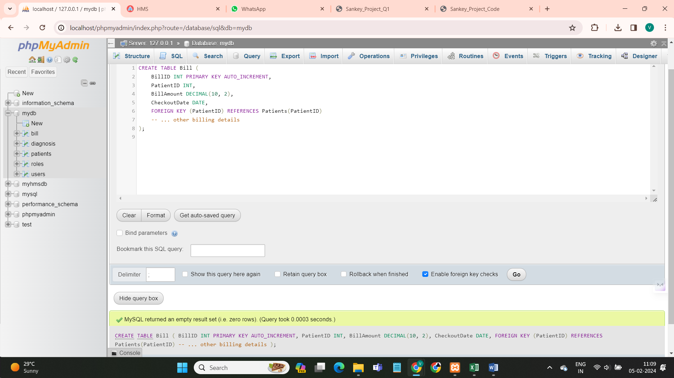

1. **Insurance Table :**

SQL Queries –

CREATE TABLE Insurance (

InsuranceID INT PRIMARY KEY AUTO_INCREMENT,

PatientID INT,

InsuranceLimit DECIMAL(10, 2),

ExpiryDate DATE,

FOREIGN KEY (PatientID) REFERENCES Patients(PatientID)

-- ... other insurance details

);

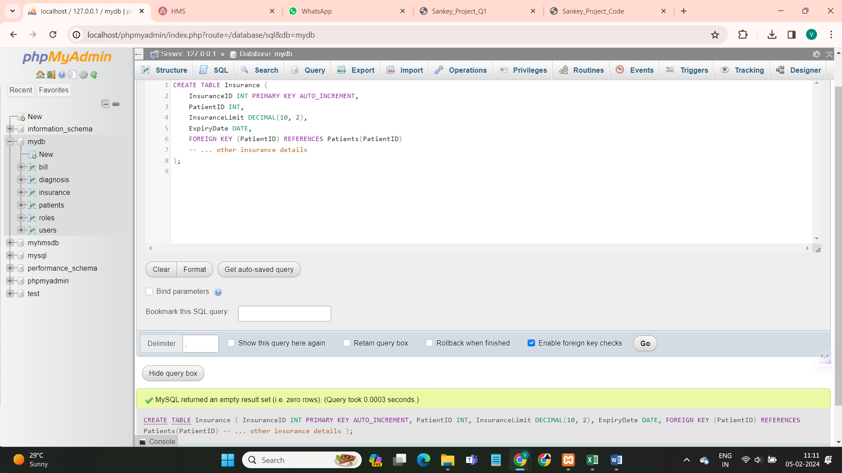

**Views , Relationships :**

CREATE VIEW PatientDetails AS

SELECT Patients.*, Diagnosis.DiagnosisDetails

FROM Patients

JOIN Diagnosis ON Patients.PatientID = Diagnosis.PatientID;

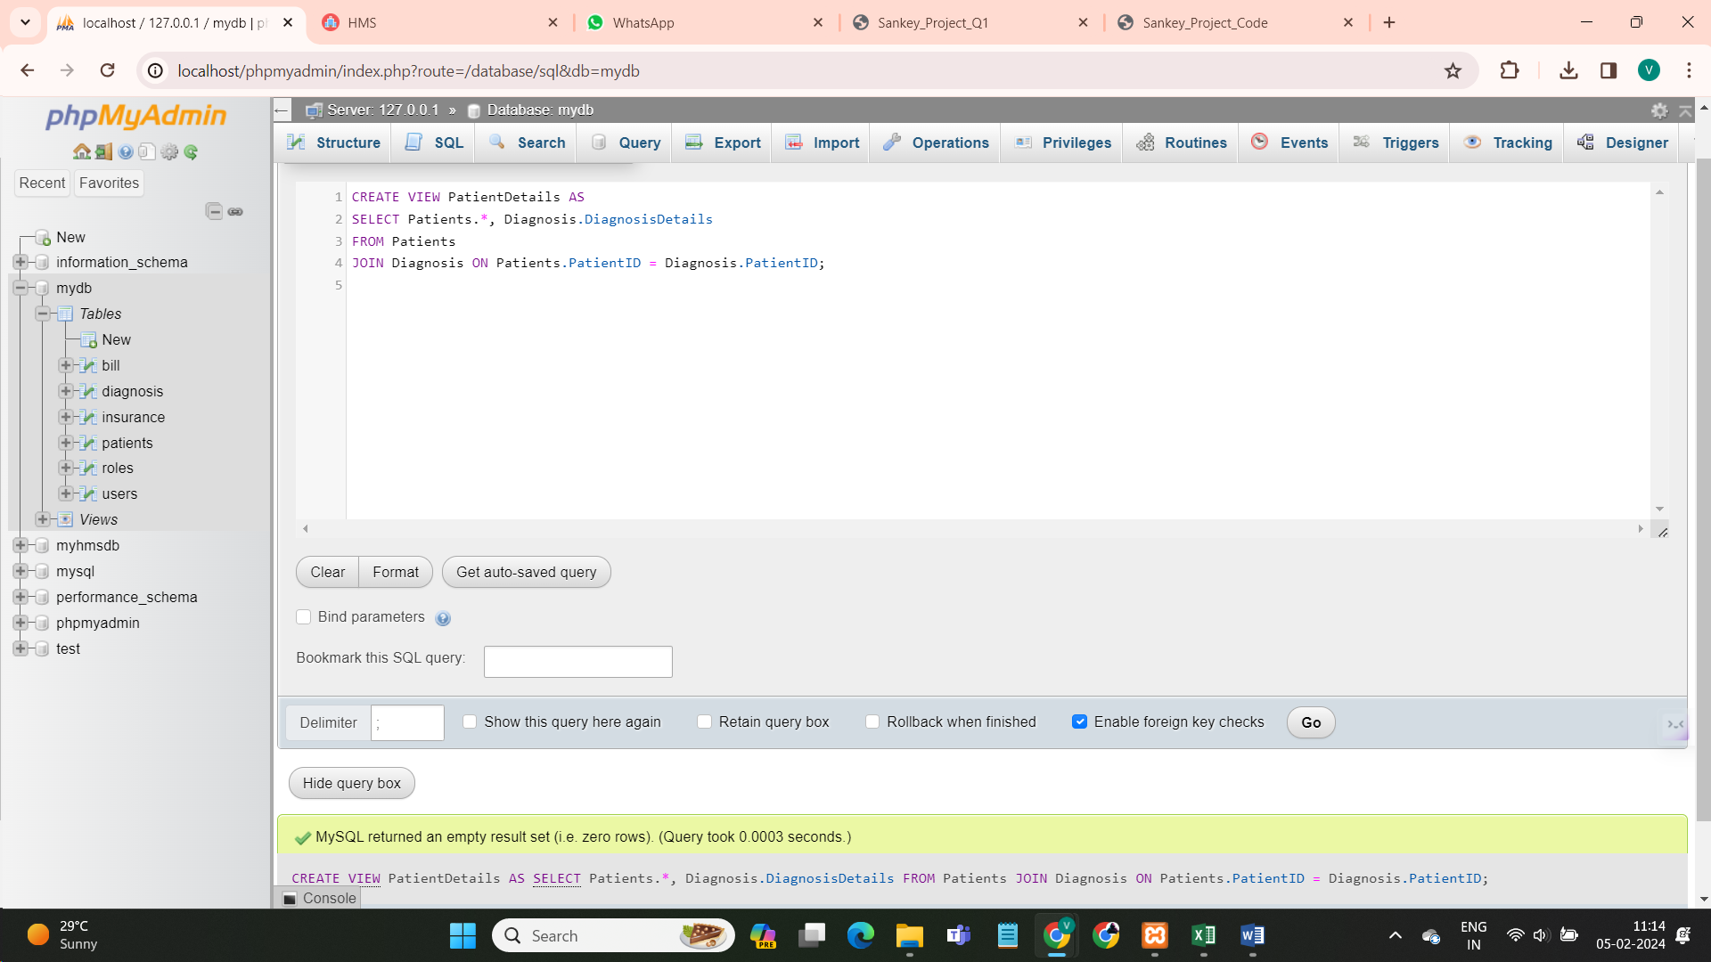

CREATE VIEW UserRoles AS

SELECT DISTINCT Role FROM Users;

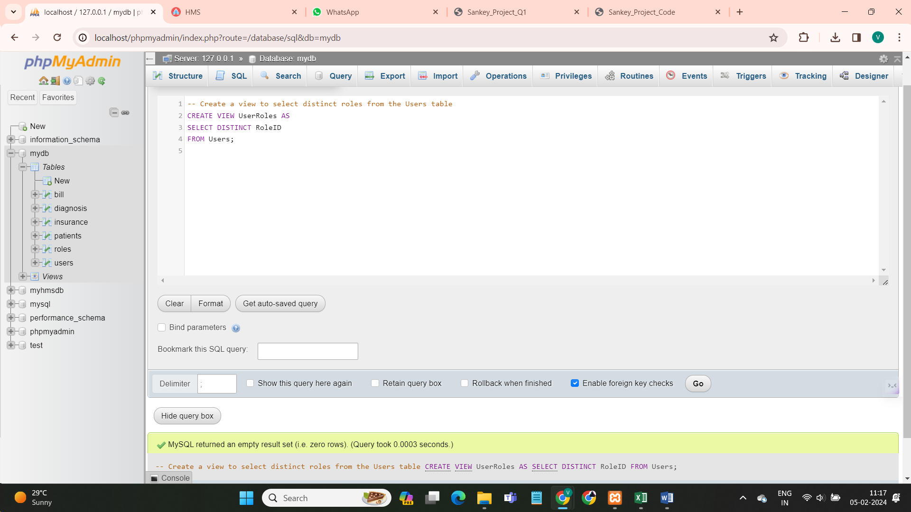

CREATE INDEX idx_PatientID ON Patients(PatientID);

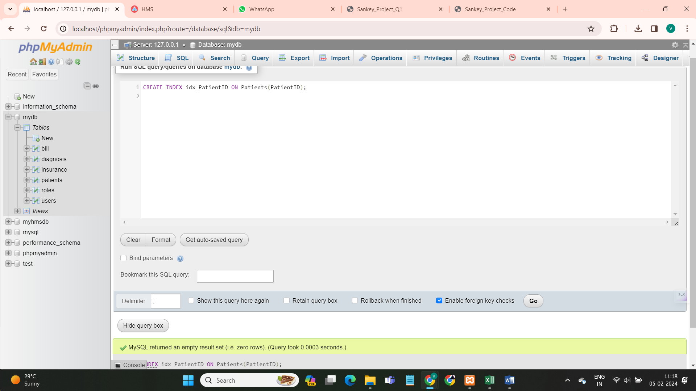

CREATE SEQUENCE Patients_Seq START WITH 1 INCREMENT BY 1;

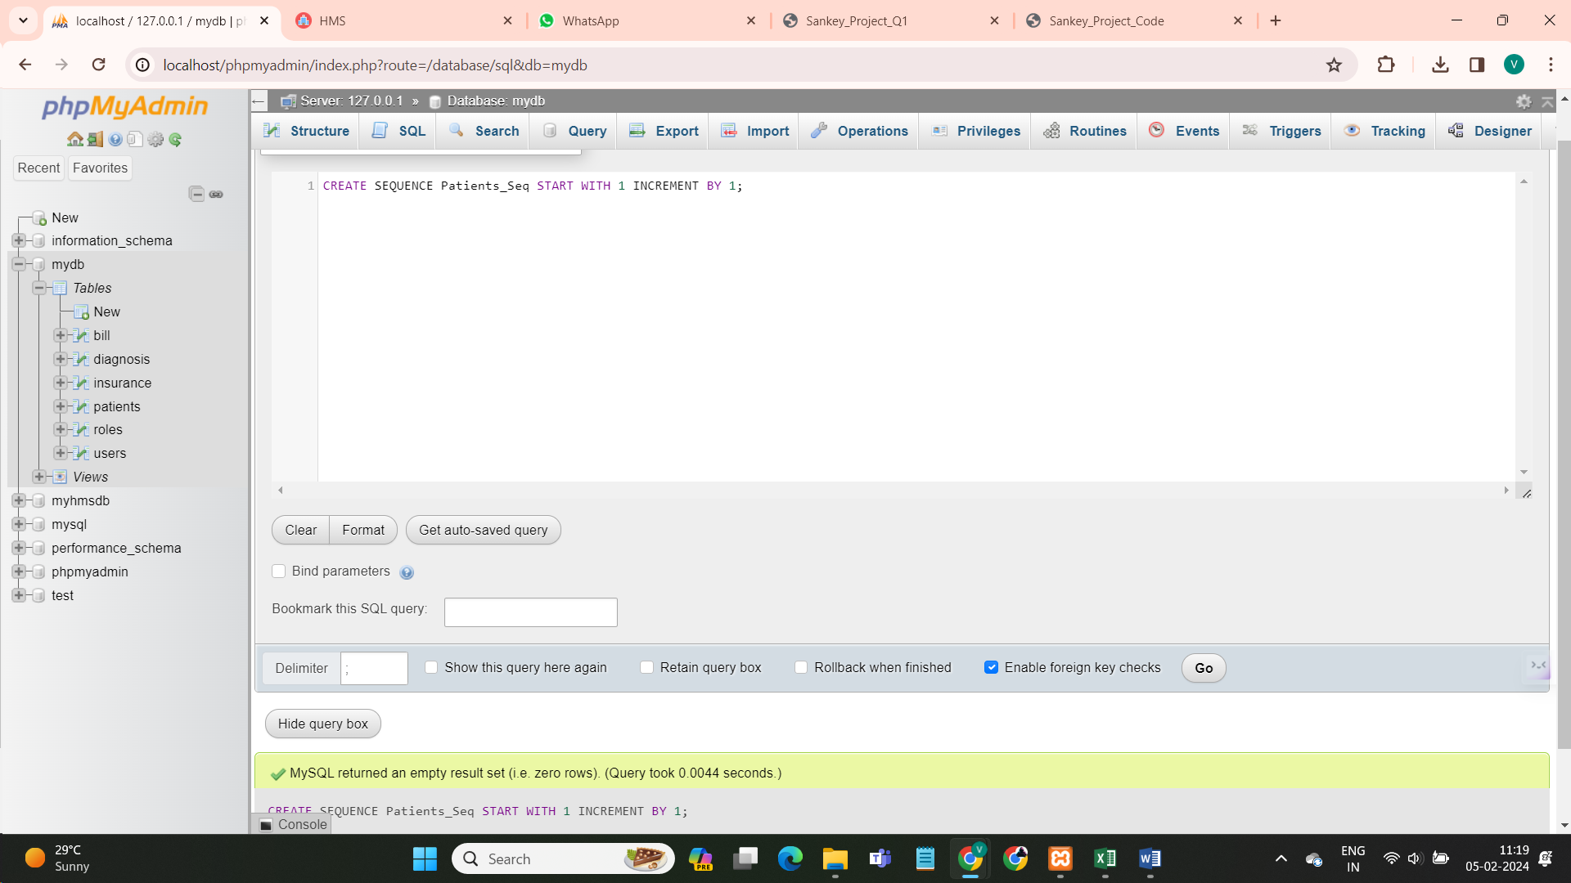

DELIMITER //

CREATE TRIGGER Patients_BeforeInsert

BEFORE INSERT ON Patients

FOR EACH ROW

BEGIN

SET NEW.PatientID = (SELECT Patients_Seq.NEXTVAL FROM DUAL);

END;

//

DELIMITER ;

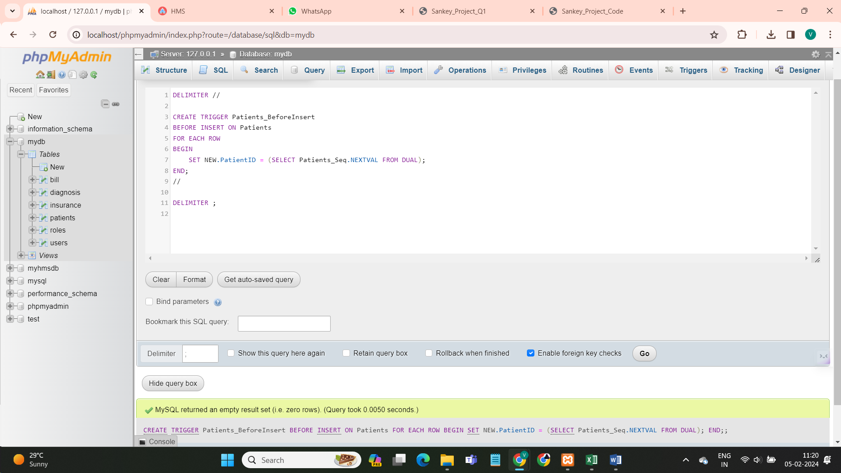

DELIMITER //

CREATE OR REPLACE PROCEDURE RegisterUserRole(IN p_Role VARCHAR(255))

BEGIN

INSERT INTO Roles (RoleName) VALUES (p_Role);

COMMIT;

END;

//

DELIMITER ;

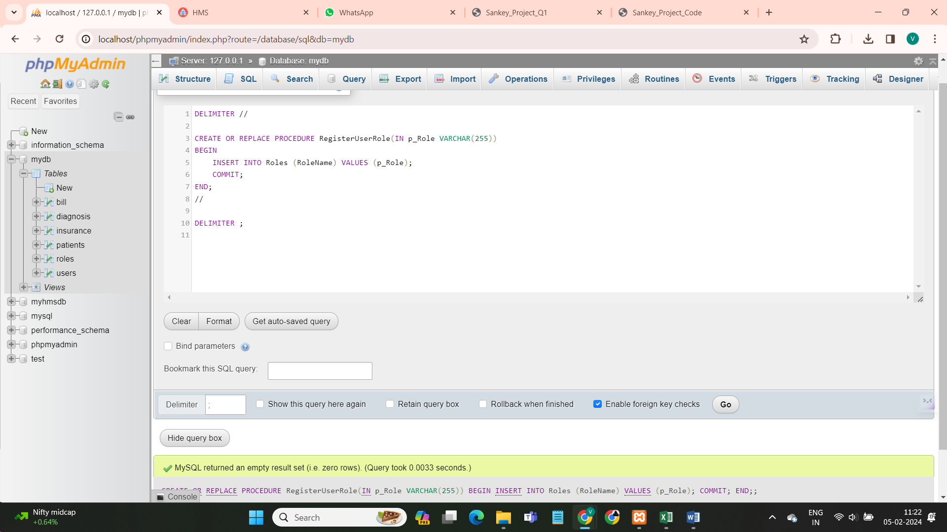

DELIMITER //

CREATE OR REPLACE PROCEDURE AddDiagnosis(IN p_PatientID INT, IN p_DiagnosisDate DATE, IN p_DiagnosisDetails TEXT)

BEGIN

INSERT INTO Diagnosis (PatientID, DiagnosisDate, DiagnosisDetails) VALUES (p_PatientID, p_DiagnosisDate, p_DiagnosisDetails);

COMMIT;

END;

//

DELIMITER ;

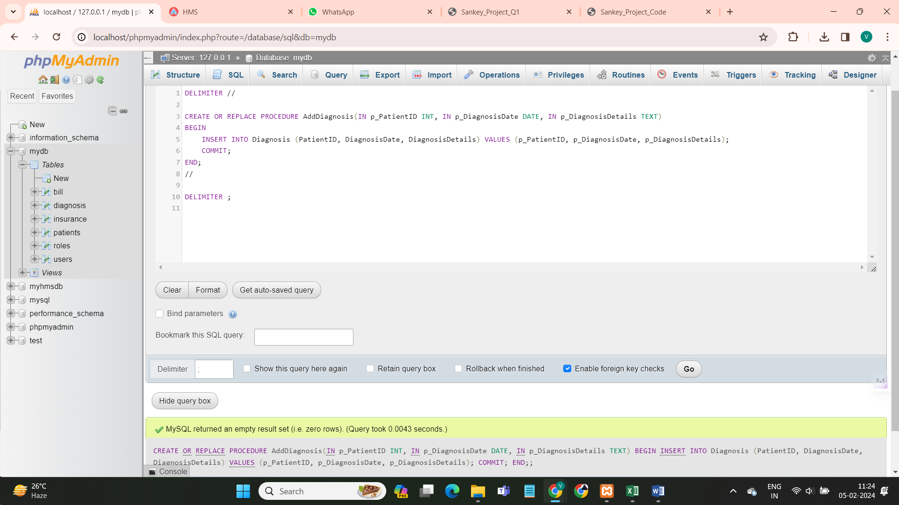

DELIMITER //

CREATE OR REPLACE PROCEDURE FetchPatientDetails(IN p_PatientID INT)

BEGIN

DECLARE v_PatientID INT;

DECLARE v_Name VARCHAR(255); -- Adjust the length as needed

SELECT PatientID, Name

INTO v_PatientID, v_Name

FROM PatientDetails

WHERE PatientID = p_PatientID;

-- Output the fetched details

SELECT 'PatientID: ' || v_PatientID, 'Name: ' || v_Name;

END;

//

DELIMITER ;

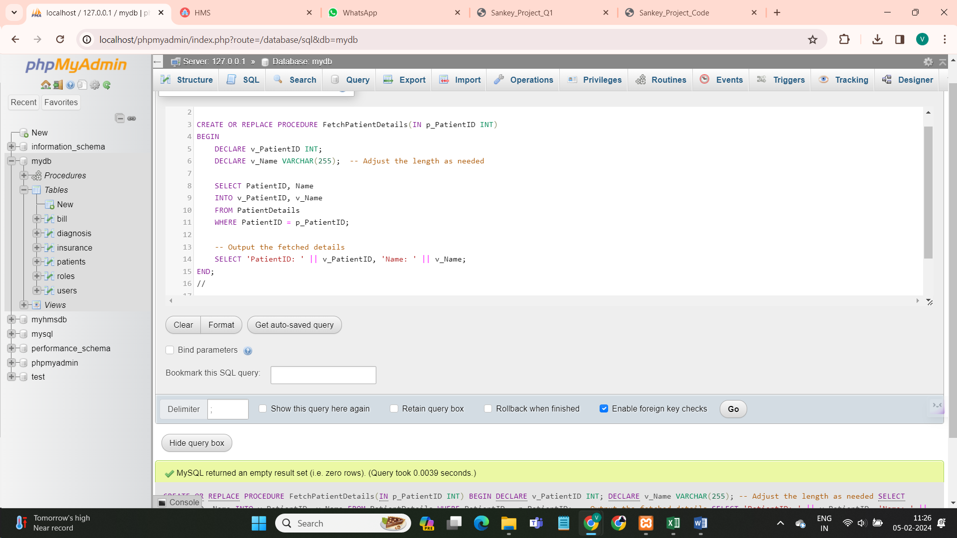

DELIMITER //

CREATE OR REPLACE PROCEDURE GenerateBill(IN p_PatientID INT)

BEGIN

DECLARE v_TotalBill DECIMAL(10, 2);

SELECT SUM(BillAmount) INTO v_TotalBill

FROM Bills

WHERE PatientID = p_PatientID;

INSERT INTO Bills (PatientID, BillAmount, BillingDate)

VALUES (p_PatientID, v_TotalBill, NOW()); -- NOW() for current date and time

COMMIT;

SELECT CONCAT('Bill generated successfully. Total amount: ', v_TotalBill) AS Message;

END;

//

DELIMITER ;

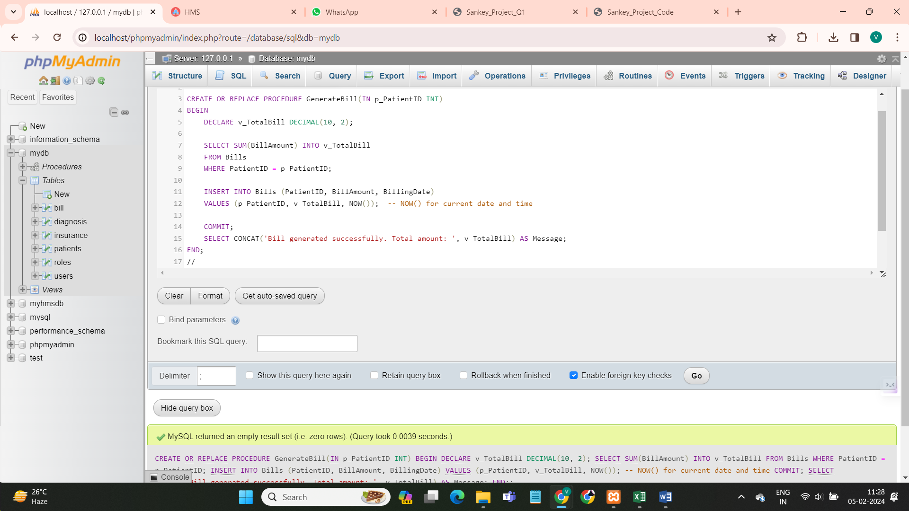

DELIMITER //

CREATE OR REPLACE TRIGGER CheckInsuranceLimit

BEFORE UPDATE ON Patients

FOR EACH ROW

BEGIN

IF NEW.InsuranceLimit <= 0 THEN

SIGNAL SQLSTATE '45000'

SET MESSAGE_TEXT = 'Patient insurance limit expired';

END IF;

END;

//

DELIMITER ;

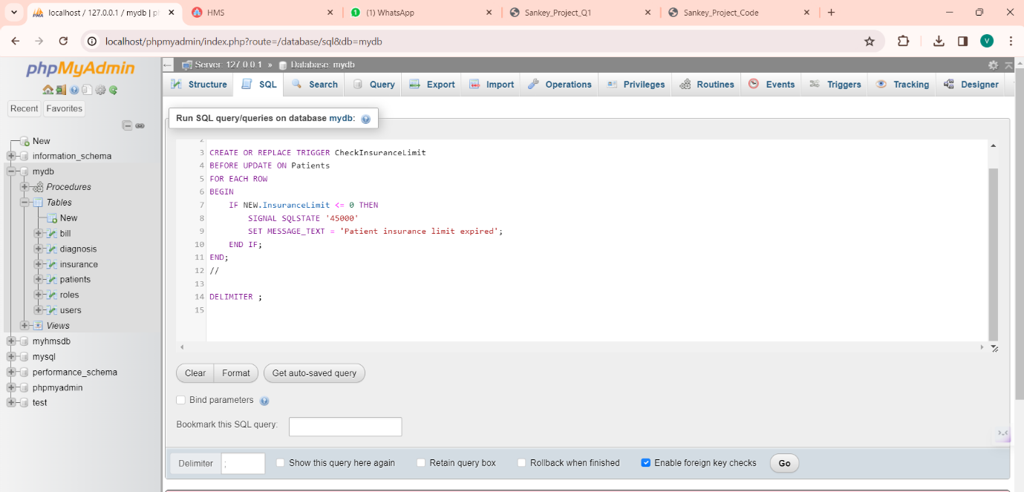

CREATE SEQUENCE UserID_Seq

START WITH 1

INCREMENT BY 1

NOMAXVALUE

NOCACHE

NOCYCLE;

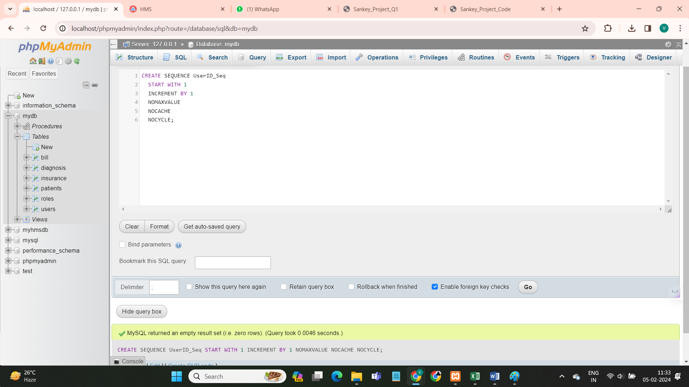

CREATE SEQUENCE DIAGNOSISID_SEQ

START WITH 1

INCREMENT BY 1

NOCACHE

NOCYCLE;

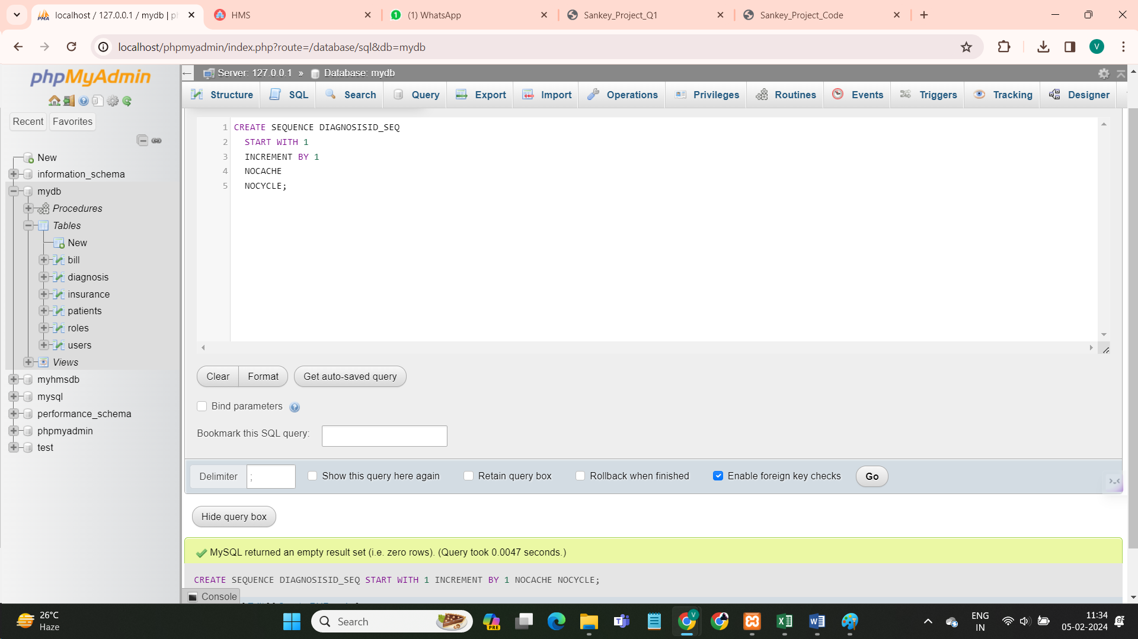

INSERT INTO patients (FirstName, LastName,Gender, DateOfBirth)

VALUES ('Vaishnavi', 'Kadam', 'Female', '1995-05-15');

INSERT INTO Users (Username, Password, RoleID)

VALUES ('vaishnavi kadam', 'password123', 'Doctor');

INSERT INTO Diagnosis (DIAGNOSISID, PatientID, DiagnosisDate, DiagnosisDetails)

VALUES (DIAGNOSISID_SEQ.NEXTVAL, 1, TO_DATE('2024-01-25', 'YYYY-MM-DD'), 'Fever');

INSERT INTO Bills (BILLID, PatientID, BillAmount, BillingDate)

VALUES (1, 1, 100.00, SYSDATE);

1. **Write necessary queries to register new user roles and personas:**

SQL Queries-

-- Insert a new role

INSERT INTO Roles (RoleName) VALUES ('Doctor');

-- Insert a new user with a role

INSERT INTO Users (Username, Password, RoleID) VALUES ('john_doe', 'password123', (SELECT RoleID FROM Roles WHERE RoleName = 'Doctor'));

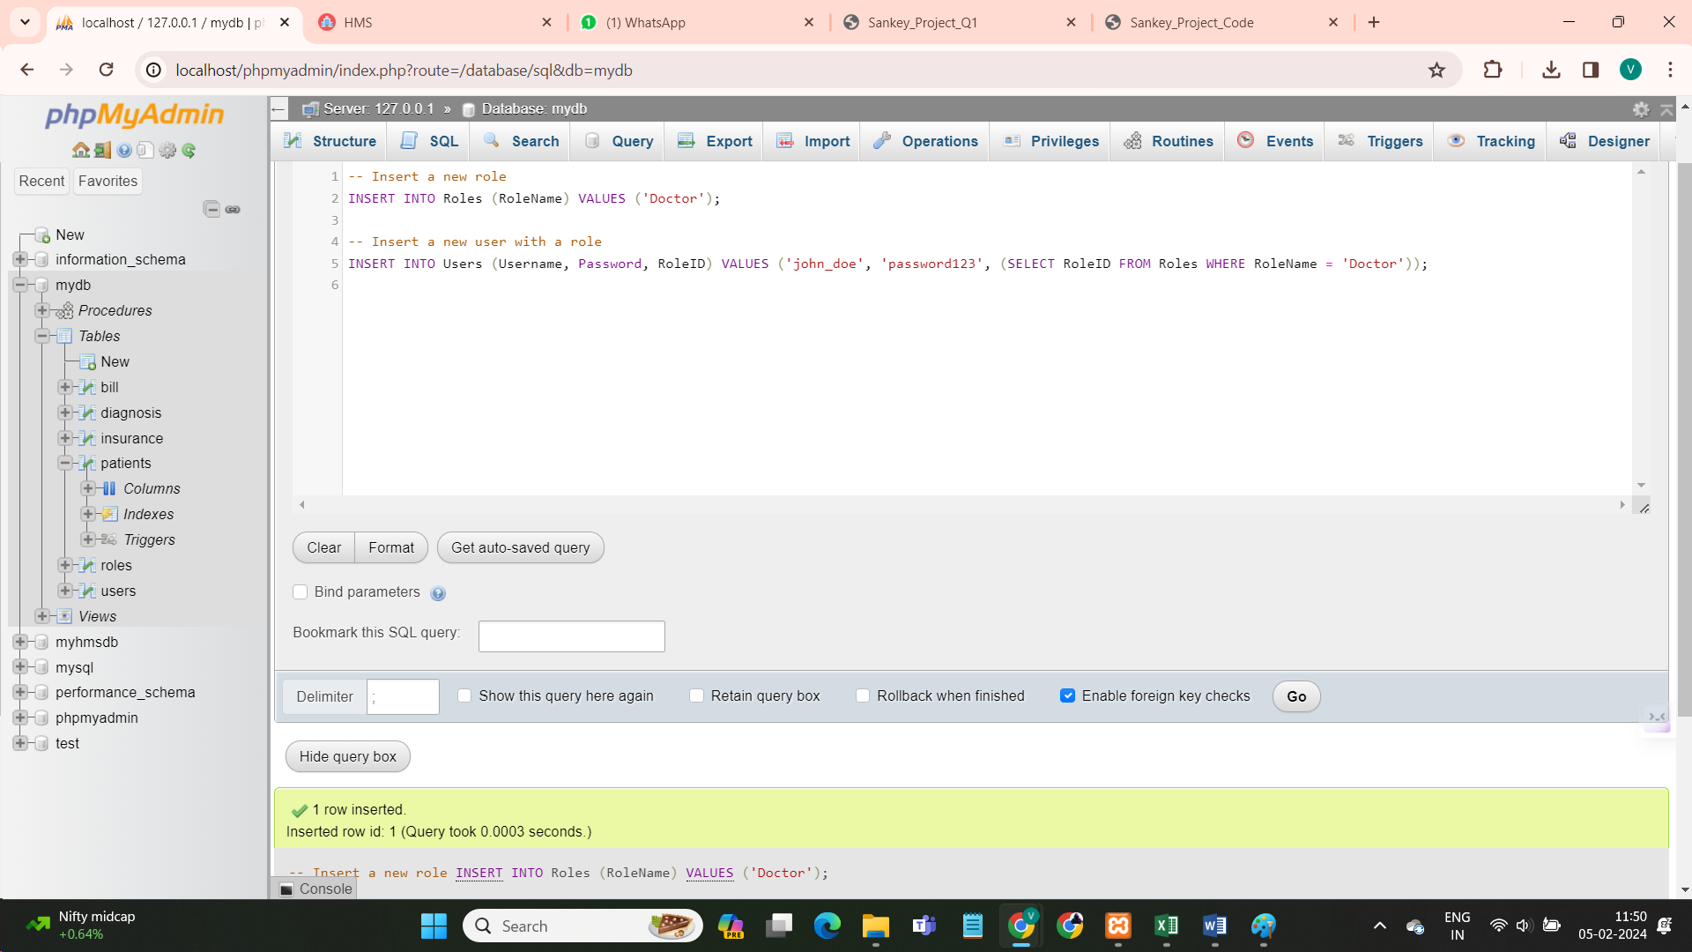

**2)Write necessary queries to add to the list of diagnosis of the patient tagged by date**

-- Insert a new diagnosis for a patient

INSERT INTO Diagnosis (PatientID, DiagnosisDate, DiagnosisDetails) VALUES (1, '2024-02-05', 'Fever and cold');

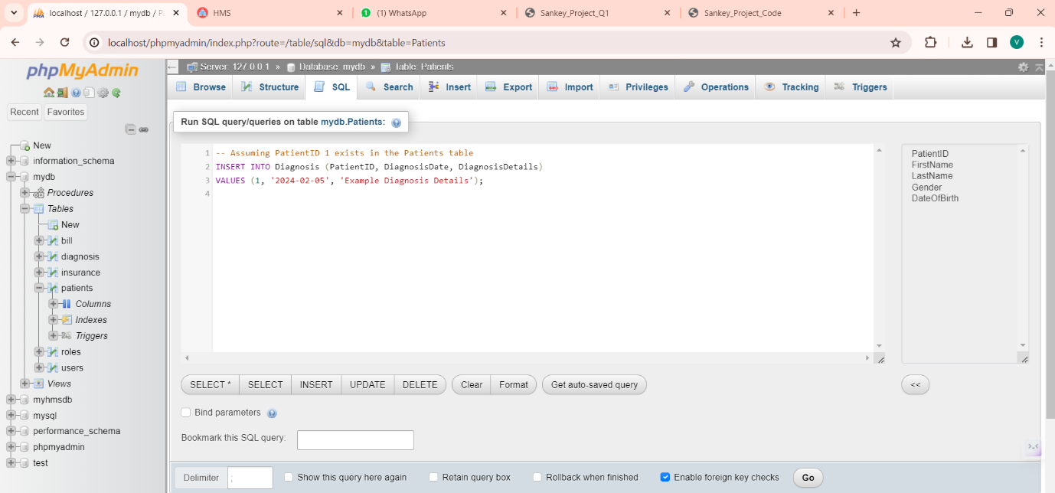

**3)Write necessary queries to fetch required details of a particular patient.**

CREATE OR REPLACE PROCEDURE FetchPatientDetails(p_PatientID NUMBER)

AS

v_PatientDetails PatientDetails%ROWTYPE;

BEGIN

FOR c IN (SELECT * FROM PatientDetails WHERE PatientID = p_PatientID) LOOP

v_PatientDetails := c;

DBMS_OUTPUT.PUT_LINE('PatientID: ' || v_PatientDetails.PatientID);

DBMS_OUTPUT.PUT_LINE('Name: ' || v_PatientDetails.Name);

END LOOP;

END;

/

**4)Write necessary queries to prepare bill for the patient at the end of checkout.**

CREATE OR REPLACE PROCEDURE GenerateBill(p_PatientID NUMBER)

AS

v_TotalBill NUMBER(10, 2);

BEGIN

v_TotalBill := 200.00;

INSERT INTO Bills (PatientID, BillAmount, BillingDate)

VALUES (p_PatientID, v_TotalBill, SYSDATE);

COMMIT;

DBMS_OUTPUT.PUT_LINE('Bill generated successfully. Total amount: ' || v_TotalBill);

EXCEPTION

WHEN OTHERS THEN

DBMS_OUTPUT.PUT_LINE('Error generating bill: ' || SQLERRM);

ROLLBACK;

END;

/

**5)Write necessary queries to fetch and show data from various related tables (Joins)**

SELECT Patients.*, Diagnosis.DiagnosisDetails

FROM Patients

JOIN Diagnosis ON Patients.PatientID = Diagnosis.PatientID

WHERE Patients.PatientID = 1;

**6)Optimize repeated read operations using views/materialized views**

DECLARE

v_PatientDetails PatientDetails%ROWTYPE;

CURSOR c_PatientDetails IS

SELECT * FROM PatientDetails WHERE PatientID = 1;

BEGIN

OPEN c_PatientDetails;

FETCH c_PatientDetails INTO v_PatientDetails;

IF c_PatientDetails%FOUND THEN

DBMS_OUTPUT.PUT_LINE('PatientID: ' || v_PatientDetails.PatientID);

DBMS_OUTPUT.PUT_LINE('Name: ' || v_PatientDetails.Name);

ELSE

DBMS_OUTPUT.PUT_LINE('Patient not found.');

END IF;

CLOSE c_PatientDetails;

END;

/

**7)Optimize read operations using indexing wherever required. (Create index on at least 1 table)**

CREATE INDEX idx_PatientID ON Patients(PatientID);

SELECT * FROM Patients WHERE PatientID = 1;

**8)Try optimizing bill generation using stored procedures**

CREATE OR REPLACE PROCEDURE GenerateBill(

p_PatientID NUMBER,

p_BillAmount NUMBER,

p_BillingDate DATE DEFAULT SYSDATE)

AS

BEGIN

IF p_PatientID IS NULL OR p_BillAmount IS NULL THEN

RAISE_APPLICATION_ERROR(-20001, 'Invalid input parameters for bill generation.');

END IF;

FOR i IN 1..10

LOOP

INSERT INTO Bills (PatientID, BillAmount, BillingDate)

VALUES (p_PatientID, p_BillAmount, p_BillingDate);

END LOOP;

COMMIT;

DBMS_OUTPUT.PUT_LINE('Bill generated successfully.');

EXCEPTION

WHEN OTHERS THEN

DBMS_OUTPUT.PUT_LINE('Error generating bill: ' || SQLERRM);

ROLLBACK;

END;

/

**9) Add necessary triggers to indicate when patients medical insurance limit has expired.**

CREATE OR REPLACE TRIGGER CheckInsuranceLimit

BEFORE UPDATE ON Patients

FOR EACH ROW

BEGIN

IF :new.InsuranceLimit <= 0 THEN

RAISE_APPLICATION_ERROR(-20001, 'Patient insurance limit expired');

END IF;

END;

/

**Constraints:**

➔ Patients Table: ◆ PatientID is the primary key.

➔ UserRoles Table: ◆ RoleID is the primary key.

➔ Users Table: ◆ UserID is the primary key. ◆ RoleID is a foreign key referencing RoleID in UserRoles.

➔ Diagnosis Table: ◆ DiagnosisID is the primary key. ◆ PatientID is a foreign key referencing PatientID in Patients.

➔ Bills Table: ◆ BillID is the primary key. ◆ PatientID is a foreign key referencing PatientID in Patients.

**Relationships:**

➔ Patients and Diagnosis: ◆ One-to-Many relationship between Patients and Diagnosis based on PatientID.

➔ Patients and Bills: ◆ One-to-Many relationship between Patients and Bills based on PatientID. ➔ Users and UserRoles: ◆ One-to-Many relationship between Users and UserRoles based on RoleID. 2 Views:

➔ Patients_view: ◆ A simple view containing all columns from the Patients table.

➔ UserRoles_view: ◆ A simple view containing all columns from the UserRoles table.

➔ Users_view: ◆ A simple view containing all columns from the Users table.

➔ DiagnosisView: ◆ A simple view containing all columns from the Diagnosis table.

➔ BillsView: ◆ A simple view containing all columns from the Bills table.

➔ PatientDetails: ◆ A view combining patient details with diagnosis and billing information.

**Indexing:**

➔ An index named idx_PatientID is created on the PatientID column of the Patients table for faster retrieval of patient information.

Stored Procedure: GenerateBill

➔ Description: ◆ GenerateBill is like a smart helper in the hospital system. It makes billing for patients easier. It puts the patient's ID, the bill amount, and today's date into the Bills list. This smart way helps keep billing organized and quick.

➔ Usage: ◆ When you want to bill a patient, just tell GenerateBill the patient's ID and the bill amount. It will take care of adding a new record in the Bills list, making billing easy and in one place. Trigger : UpdateInsuranceLimit

➔ Description: ◆ The UpdateInsuranceLimit trigger ensures accurate insurance details. When a new bill is added, it automatically updates the patient's insurance limit in the Patients list by deducting the new bill amount (NEW.BillAmount). This smart update keeps the insurance limit current at all times.

➔ Usage: 3 ◆ Without any manual input, the trigger works seamlessly whenever a new bill is added. It takes care of updating the Patients list, ensuring that insurance details stay accurate and timely after each new bill insertion.

**ER Diagram :**

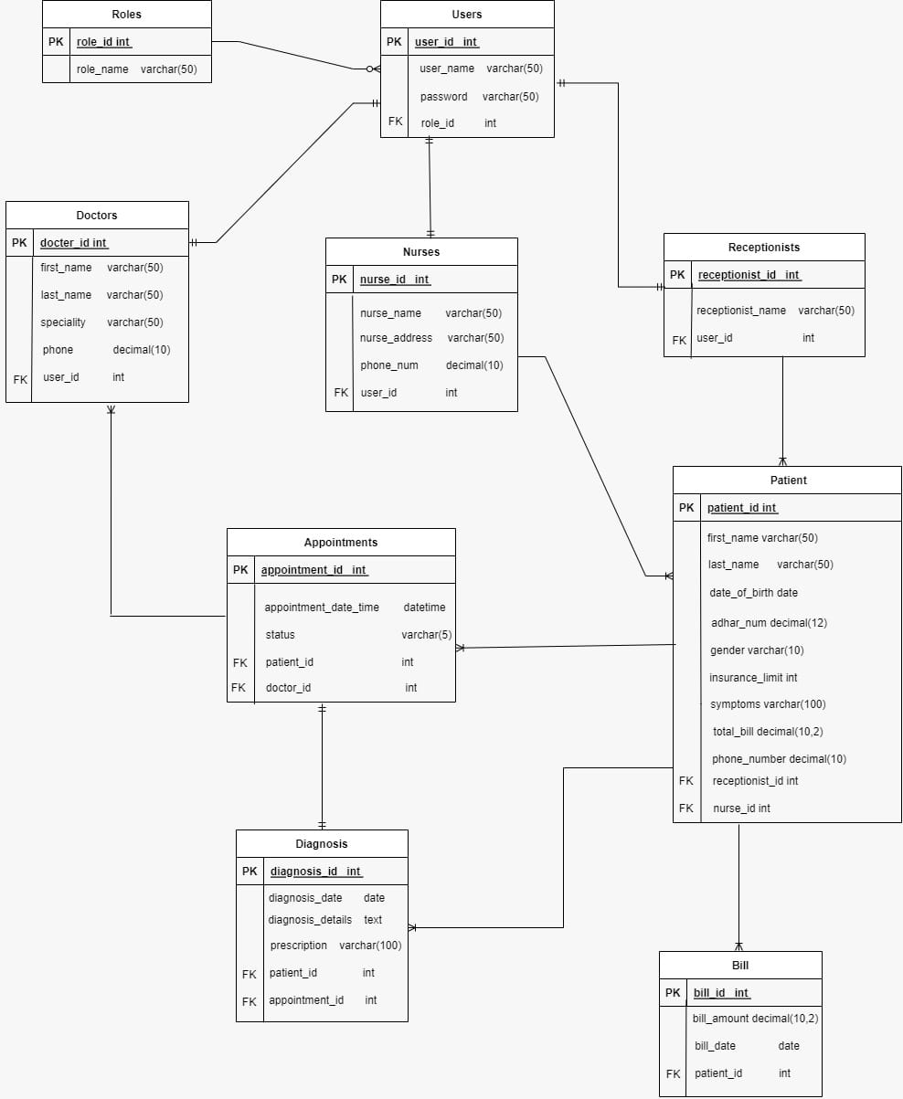

**Normalize Schema:**

First Normal Form (1NF): ● Remove redundancy by splitting the Name field into FirstName and LastName. ● Each column should hold atomic values. ● UserRoles Table ,Users Table,Diagnosis Table,Bills Table already in 1NF 4

Second Normal Form (2NF): In 2NF, all table information relies fully on the primary key, preventing partial dependencies. For instance, in the Patients table, details like Date of Birth link solely to the PatientID, ensuring a complete connection.

Third Normal Form (3NF): In 3NF, transitive dependencies are eliminated, enhancing data integrity. The schema is structured this way to reduce redundancy, enabling efficient data management.

**Conclusion** : In conclusion, the Hospital Management System project efficiently organizes patient data, streamlines billing processes, and ensures real-time insurance updates. Stored procedures, triggers, and views enhance system accuracy and efficiency.